“TeamSpark”

TeamSpark is a 4 member’s team consists of **Lavanya Mattaparthi, Kruthika UmmadahalliSomaraju, Harshita Singh** and **Khanom Meshkat Hassan Beiki.** TeamSpark key strengths are Quick learning, hardworking and good at problem-solving.

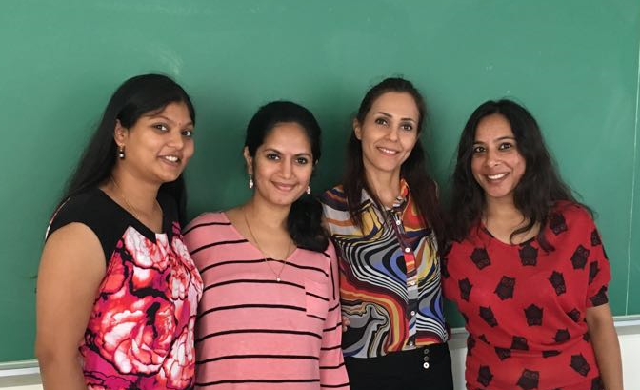

Let’s take a moment to introduce each member in TeamSpark.

**Lavanya Mattaparthi**

|  |  |
| --- | --- |
|  | Lavanya Mattaparthi grew up in Amalapuram, India and completed her bachelor's in ***Electrical and Electronics Engineering*** from ***BVC institute of technology and science*** with distinction in 2013. In her academics, she presented a project titled “***Secured Power Transmission with loss analysis***”, the project grabbed the attention of my professionals leading it to be one of the best projects in that year. Later she joined as a faculty in ***RMJ automation and training Pvt. ltd***. Currently, she is pursuing masters in computer information technology with computer science as major expected to graduate in May 2017, in her curriculum, she gained knowledge on JAVA, C, Data structures, HTML, and Networking methodologies. |

**Kruthika UmmadahalliSomaraju**

|  |  |
| --- | --- |
|  | Kruthika UmmadahalliSomaraju is a student at CCSU pursuing MS in computer information technology with computer science as major expected to graduate in May 2017, she was born in Mandya (India) and did her schooling in ***Carmel convert high school*** and graduated from ***Viswevariah Technological University*** at Bangalore (India) with a Bachelor of Engineering in May 2008. She later worked as a software tester in ***Target Corporation*** and worked on many HR applications like PeopleSoft, SAP, Workforce Management, etc. In her curriculum, she gained good knowledge on Java, Database Systems, Algorithms, Web Programming which are her favorite topics. |

**Harshita Singh**

|  |  |
| --- | --- |
|  | Harshita Singh is a student of MS-CIT program and currently in her third semester. She is working On-Campus as a ***Graduate Assistant*** under Chairman Peter Bauman in the Engineering department. She is an International student from India and done her graduation in ***Commerce*** and Masters in ***MBA***. To gain the technical knowledge she is currently pursuing her double Master’s in Computer Science and so far she has learnt java, database, data structures, networking concepts, etc. Earlier she was working as a ***SAP consultant*** in an IT company based in India. Her goal is to work with the employee-centric IT giants like Google, Microsoft, where she can use her technical and management skills. She is a hard-working and self-motivated person who focuses on converting her dreams into reality. |

**Khanom Meshkat Hassan Beiki**

|  |  |
| --- | --- |
| image1 | Khanom Meshkat Hassan Beiki was born in Tehran, Iran, in 1974. She landed in United State on Oct 2013 along with her daughter. She completed bachelor's in ***Medical Librarianship and Information*** at ***Iran University of Medical Science,*** Tehran, Iran in 1997 and completed masters in ***Medical Informatics & Health Economics*** in the same institute in 2012 and she worked at **Central library of the university** between 1997-2013 as a ***Digital librarian*** and ***reference librarian***. She achieved multiple certifications in computers as well as medical science sector. Currently, she gained knowledge on Java, Data structure, and networking concepts. |

**Our first meeting at cafeteria:**

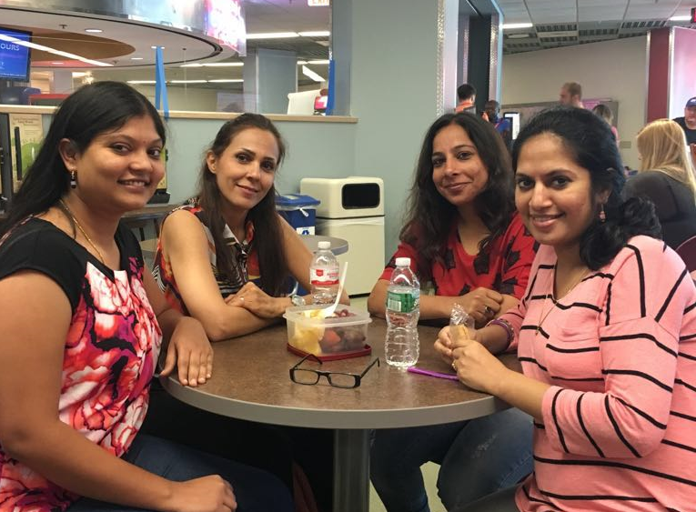

In the meeting, the team discussed a couple of rules and came up with the following agreement.

From TeamSpark **Lavanya** **Mattaparthi** will be the main contact person to interact with the instructor.

Team GitHub ID’s

|  |  |
| --- | --- |
| **Name** | **Github ID** |
| Lavanya | LavanyaMattaparthi |
| Kruthika | Kruthikaummadahallisomaraju |
| Harshita | Harshita01 |
| Nushin | khanomMeshkatHassanBeiki |

Team agreed to follow following guidelines –

1. Methods of communication

**WhatsApp:** Separate dedicated group created for the team to communicate during software engineering project, so that communication can happen in real time.

**Face to face meetings**: Meetings to discuss project progress and its current status.

**Phone:** For immediate communication between team members.

**Email:** For all other communications and to share any files between team members.

1. Communication response times

* Text: Maximum 15 mins
* Phone: Immediate or 2min (if not in any scheduled class)
* Email: Response time would be 3 hours

1. Meeting attendance

* All 4 members should attend the meeting and it will be scheduled twice a week (Monday and Wednesday).
* Attending status meetings are mandatory for all the members.

1. Running meetings

* TeamSpark agreed to have meetings at CCSU student center, which will be a face to face meeting because this would make our understanding better.
* Team member **Harshita** will take the minutes of the meeting and communicate to all members.

1. Meeting preparation

* Yes, Team feels preparation is very much required before joining for a meeting.
* Harshita will setup and share the agenda for meetings.

1. Version control

* Currently, Team has not planned for any Version control tools, but any documents and log message will be reviewed by the team before sharing.

1. Division of work

* **Kruthika** will make a decision on dividing and distributing the work within the project team members.

1. Submitting assignments

* The team makes sure that they submit assignments on time.
* All team members review the assignments before **Meshkat** submits them.

1. Contingency planning

* TeamSpark has planned to move ahead and not to stop any work if any team member misses meetings or academically dishonest.
* All activities performed by individual team members share within the team, by any chance if one member drops out then other team members can continue without any hiccups.